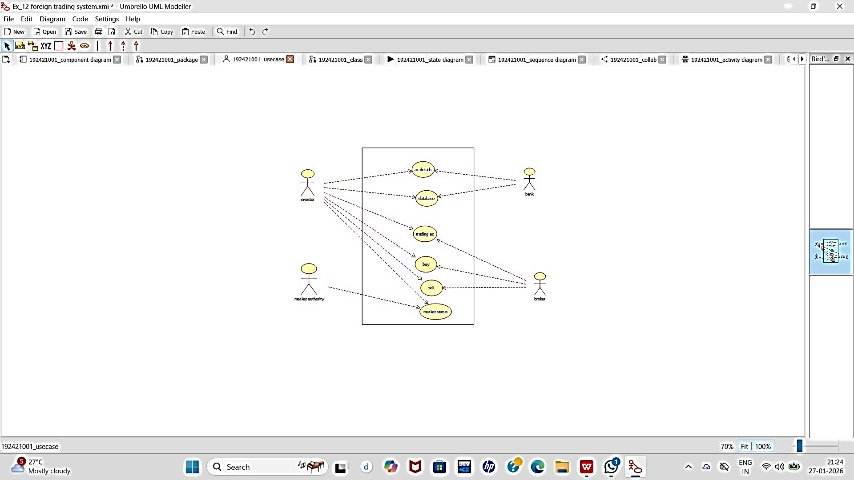
USE CASE DIAGRAM:

CLASS DIAGRAM:

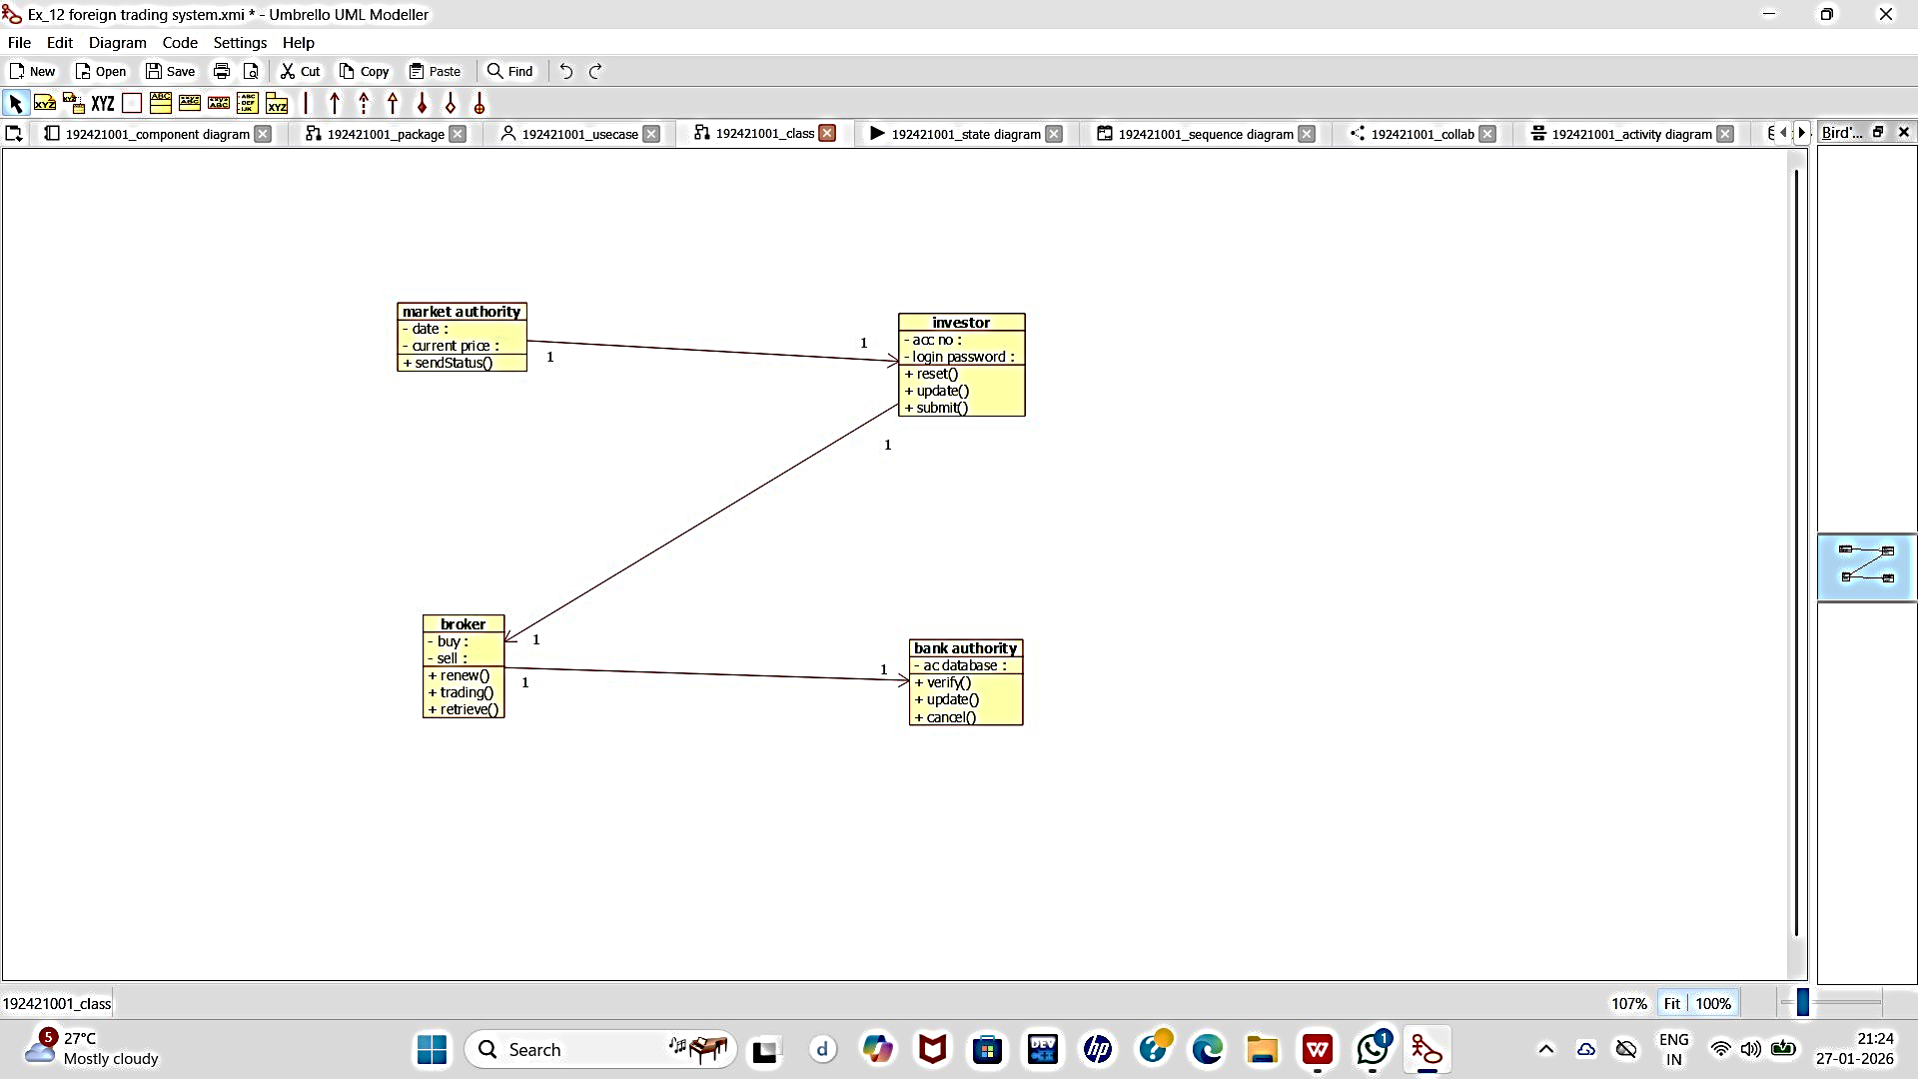

ACTIVITY DIAGRAM:

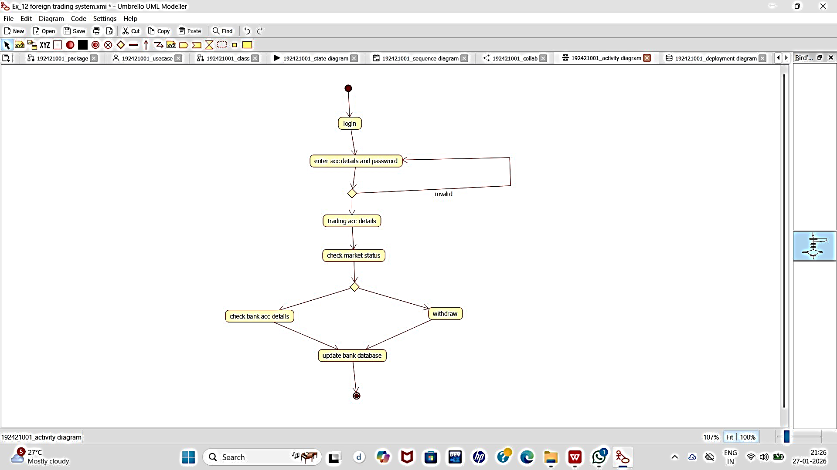

SEQUENCE DIAGRAM:

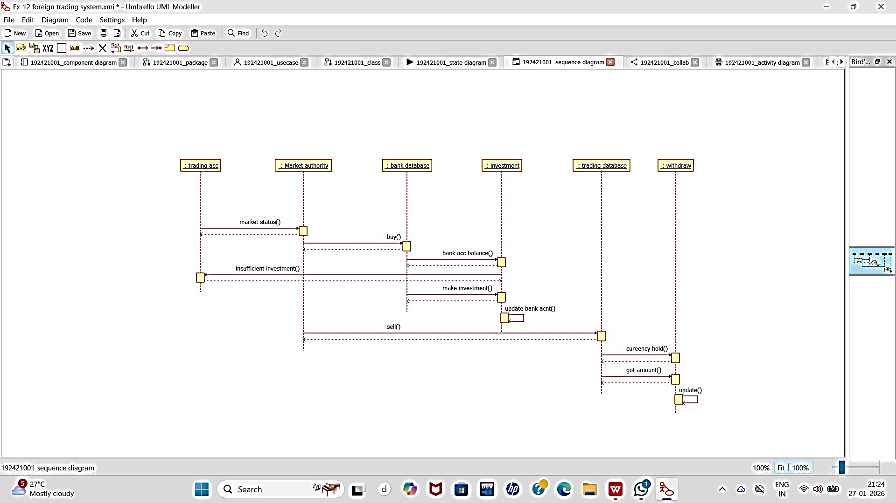

COLLABORATION DIAGRAM:

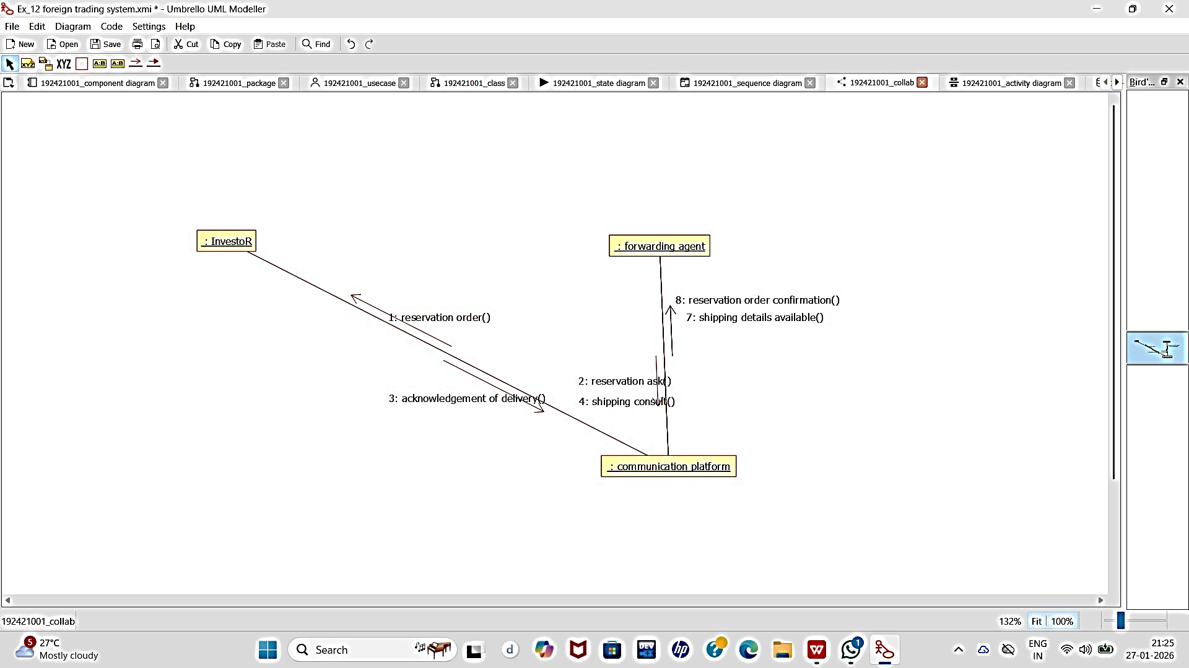

STATECHART DIAGRAM:

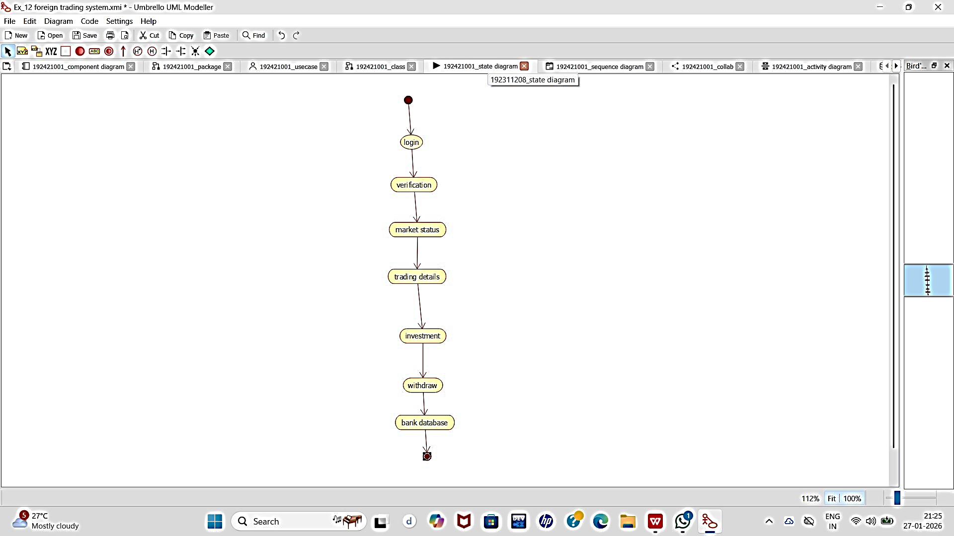

COMPONENT DIAGRAM:

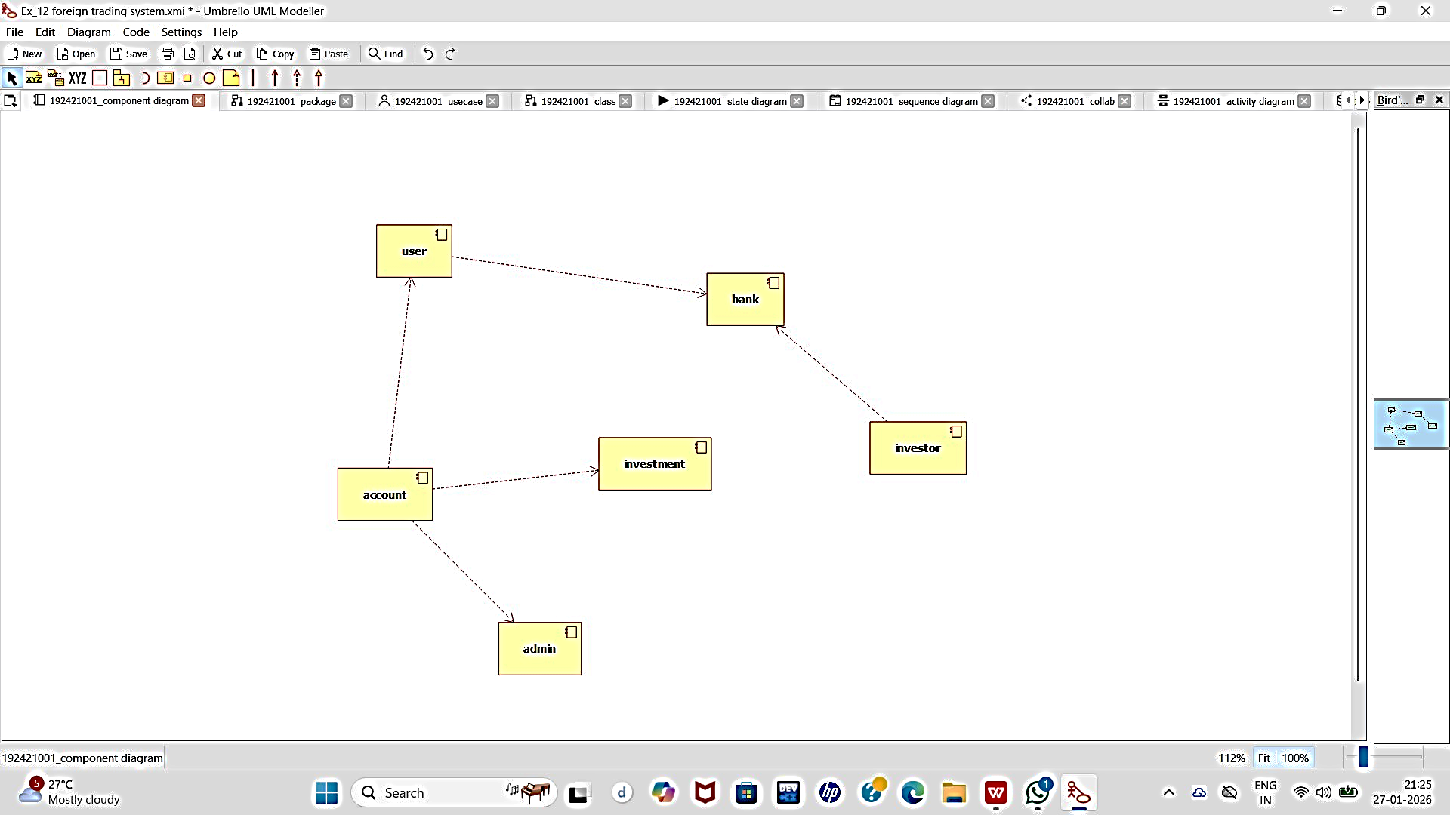

DEPLOYMENT DIAGRAM:

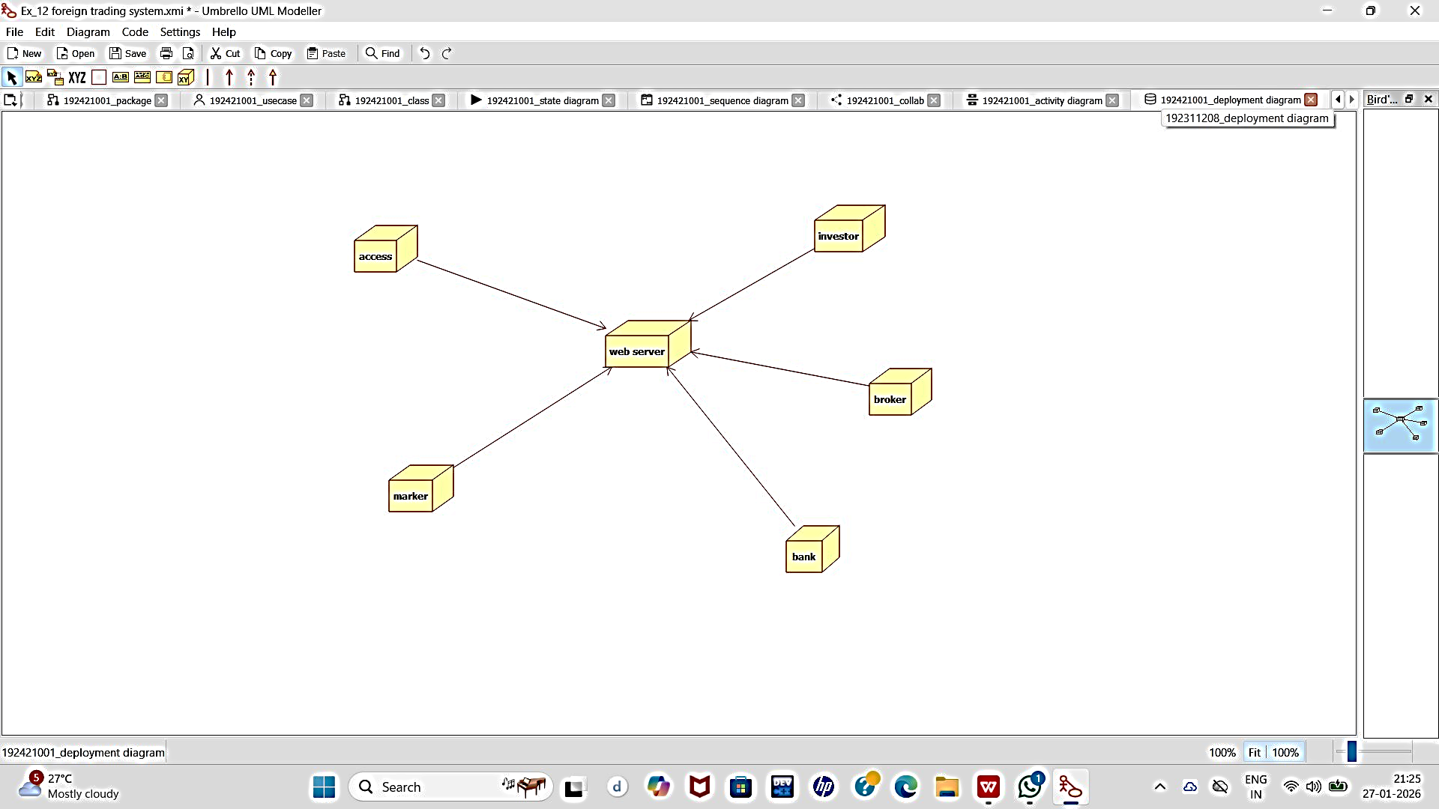

PACKAGE DIAGRAM:
